1.**resources/views/front/layout.blade.php**

@admin

<a class="dropdown-item" href="{{route('dashboard')}}">Dashboard</a>

@endadmin

**@auth**

**<a class="dropdown-item" href="{{route('messages')}}">Messages</a>**

**@endauth**

2.**routes/web.php**

Route::middleware('auth')->group(function () { //!!!ONLY AUTH-USERS

…

**Route::name('messages')->get('/messages', 'MessageController@index');**

});

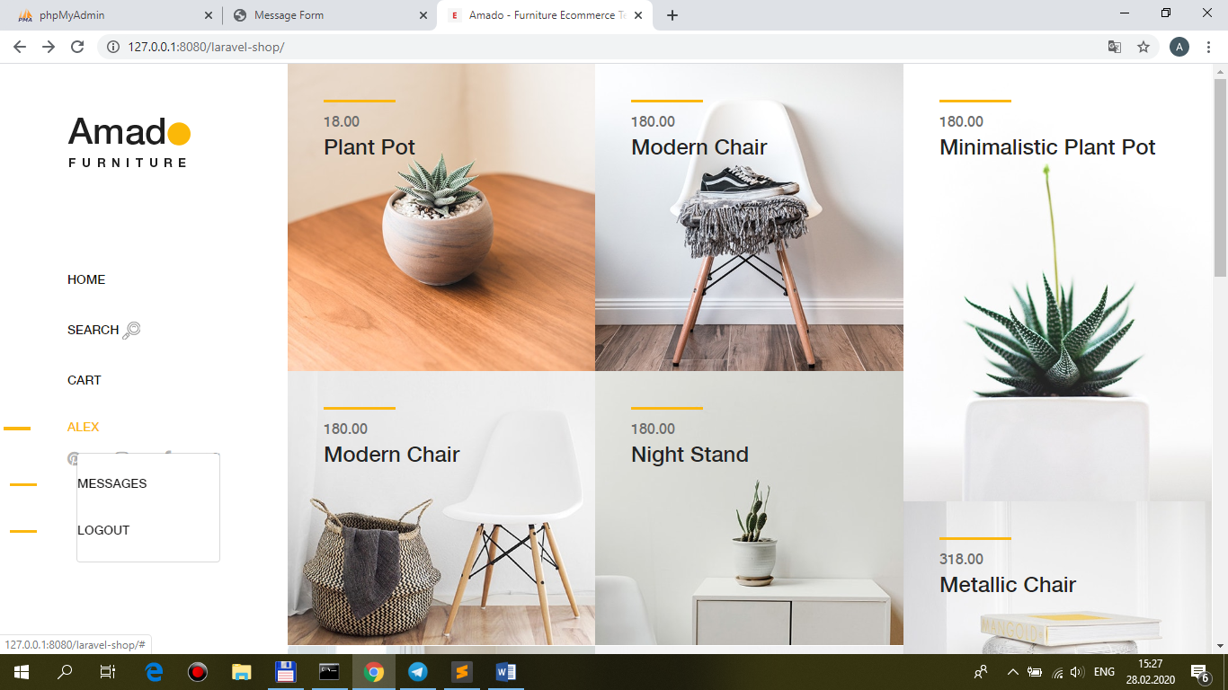

3.**app\Http\Controllers\Front\MessageController.php**

<?php

namespace App\Http\Controllers\Front;

use Illuminate\Http\Request;

use App\ {

Http\Controllers\Controller,

**Repositories\MessageRepository**

};

class MessageController extends Controller

{

/**

* Create a new controller instance.

*

* @return void

*/

protected $repository;

/**

* Create a new controller instance.

*

* @return void

*/

public function __construct(MessageRepository $repository)

{

//$this->middleware('auth');

$this->repository = $repository;

}

/**

* Show the home-page.

*

* @return \Illuminate\Contracts\Support\Renderable

*/

public function index(Request $request)

{

$messages = $this->repository->funcSelect($request);

return view(**'front.messages.index'**, ['messages' => $messages]);

}

}

4.**app\Repositories\MessageRepository.php**

?php

namespace App\Repositories;

use App\Models\ {

**Apimessage**

};

class MessageRepository

{

/**

* The Model instance.

*

* @var \Illuminate\Database\Eloquent\Model

*/

protected $model_message;

/**

* Create a new MessageRepository instance.

*

* @param \App\Models\Apimessage $message

*/

public function __construct(Apimessage $message)

{

$this->model_message = $message;

}

/**

* Create a query for Apimessage.

*

* @return \Illuminate\Database\Eloquent\Builder

*/

public function funcSelect($request)

{

$query = $this->model_message

->select('id', 'user_id', 'title', 'message', 'datevisit')

->orderBy('datevisit', 'desc');

return $query->get();

}

}

5.**resources\views\front\messages\layout.blade.php, index.blade.php, brick-standard.blade.php (copy from !here(laravel-shop) views/back and change(index.blade.php))**

**layout.blade.php – not change**

**brick-standard.blade.php**

<td class="center widthbutton"><a class="btn btn-danger listbuttonremove" href="#"><i class="fa fa-trash-o" aria-hidden="true"></i></a></td>

<td class="col-md-6 col-sm-6 col-xs-6 center widthbutton"><a class="btn btn-primary listbuttonupdate" href="#"><i class="fa fa-edit" aria-hidden="true"></i></a></td>

**index.blade.php**

@extends(**'front.messages.layout'**)

@section('css')

@endsection

@section('main')

<div class="row padding_body">

<div class="col-md-12">

<div class="box box-primary">

<div class="box-body">

<div id="spinner" class="text-center"></div>

<div class="table-responsive">

@if (session('**message**-updated'))

@component('back.components.alert')

@slot('type')

success

@endslot

{!! session('**message**-updated') !!}

@endcomponent

@endif

<table>

<thead>

<tr>

<td class="widthbutton">&nbsp;</td>

<td class="widthbutton">&nbsp;</td>

<td>User Name</td>

<td>Title</td>

<td>Message</td>

<td>Date of visite</td>

</tr>

</thead>

<tbody id="pannel">

@ //include(**'front.messages**.brick-standard')

</tbody>

</table>

</div>

</div>

</div>

</div>

</div>

</section>

@endsection

@section('js')

<script src="{{ asset('public/js/mine.js') }}"></script>

<script>

//...

</script>

@endsection

